**Shared points across all approaches**

Some points that are consistent across all approaches

* The same dataset
* I’ve used a custom test-train-validation split that respects the temporal order of the data. This split is perhaps unusual, in that it holds out only 7 days respectively for test and validation sets. However, this decision was based on reasons:
  + the ACF plot, which indicated that the ideal sequence length is a multiple of 1 day,
  + experimentation which showed that 7 days generalises best. The implication is that this model needs to be retrained weekly.
  + Our objective was to generate a better 7-day forecast.

**Exponential Smoothing**

Holt-Winters or triple exponential smoothing, is one of the oldest statistical techniques for time series modelling.

More about this

**Prophet**

I confess that I had very low expectations of Prophet when we started. It gets a lot of criticism in data science circles. I understand from the documentation that Facebook Prophet is “fully automatic” and “tunable”, which means it can be as complicated or as simple as you want it to be.

It is a decomposable time series model with trend, seasonality, and holidays. It is quite similar to a Generalised additive Model, but with all the complexity abstracted away. It has am interesting wrapper that abstracts away much of the complexity required to build a SARIMA model from scratch. It enables the users to build optimised statistical time series without getting under the hood.

The API is not intuitive, but its difficulty has been overblown. For some reason it just doesn’t feel pythonic to me, and I spent a lot of time with the documentation on this one in order to get it working. The effort was worth it though as Prophet delivers surprisingly good forecasts with little code and some really nice integrations including:

* decomposition into components: trend, seasonality, noise etc
* time series cross validation: this is the magic sauce – easily implementing time series CV to optimise the statistical model
* WandB integration for sweeps and experiment tracking

**Hyper parameter sweeps image**

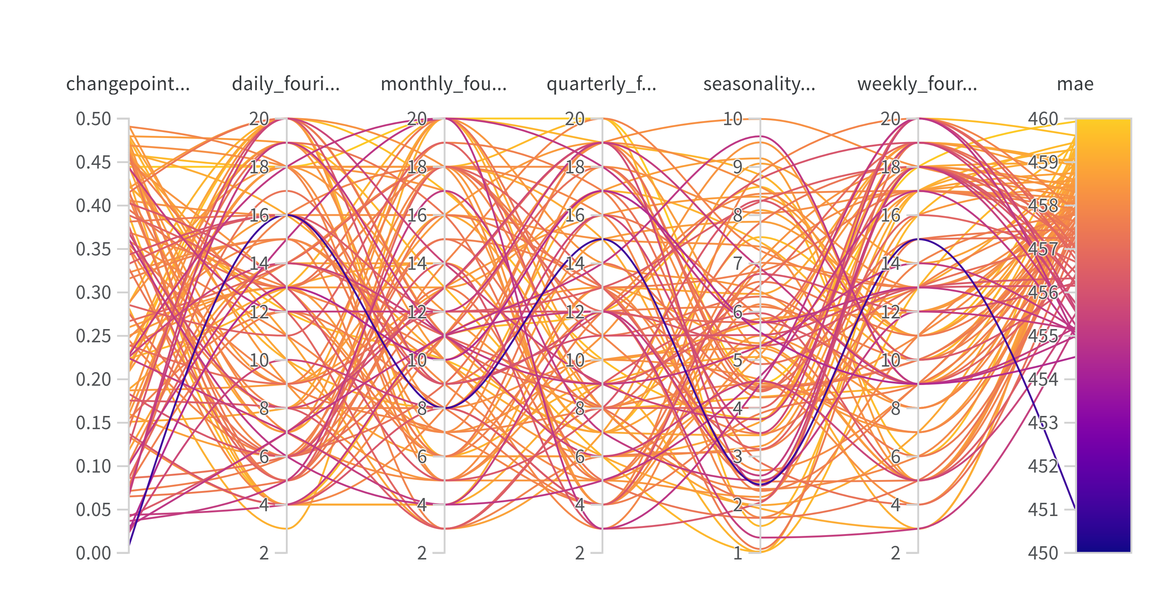

**Hyperparameter importance image**

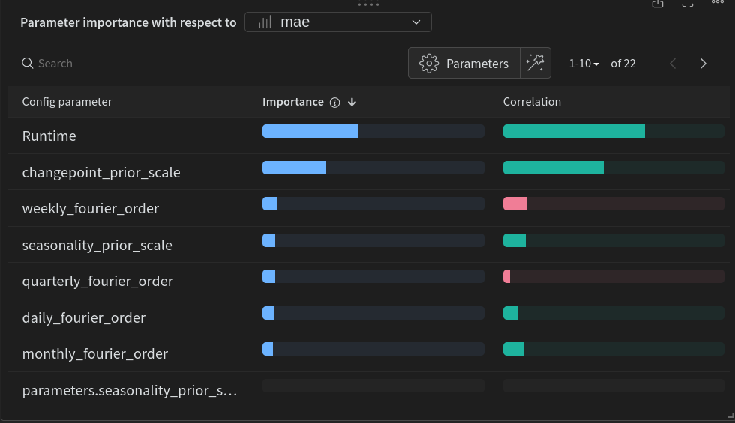

**Forecast validation set Actual vs Forecast image**

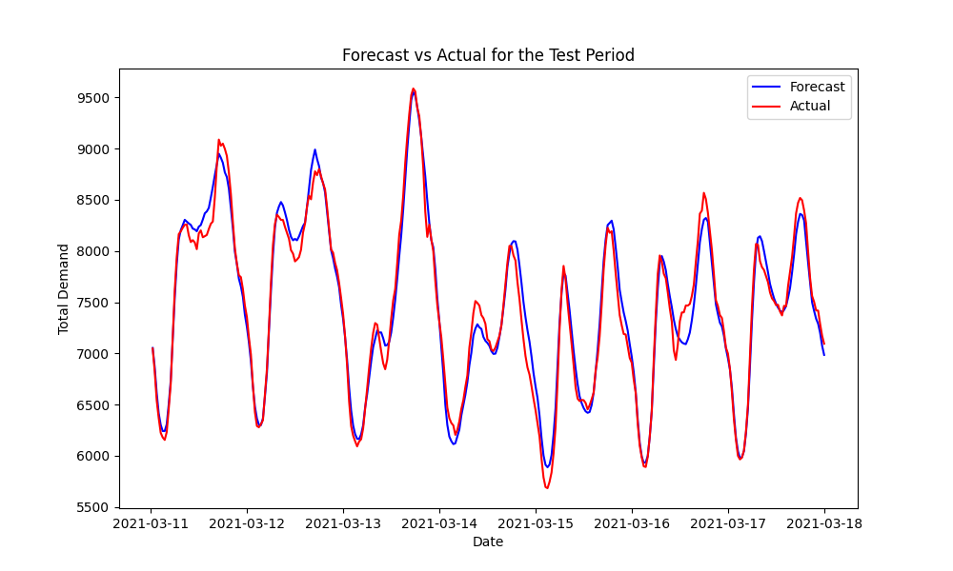

**Prophet components image**

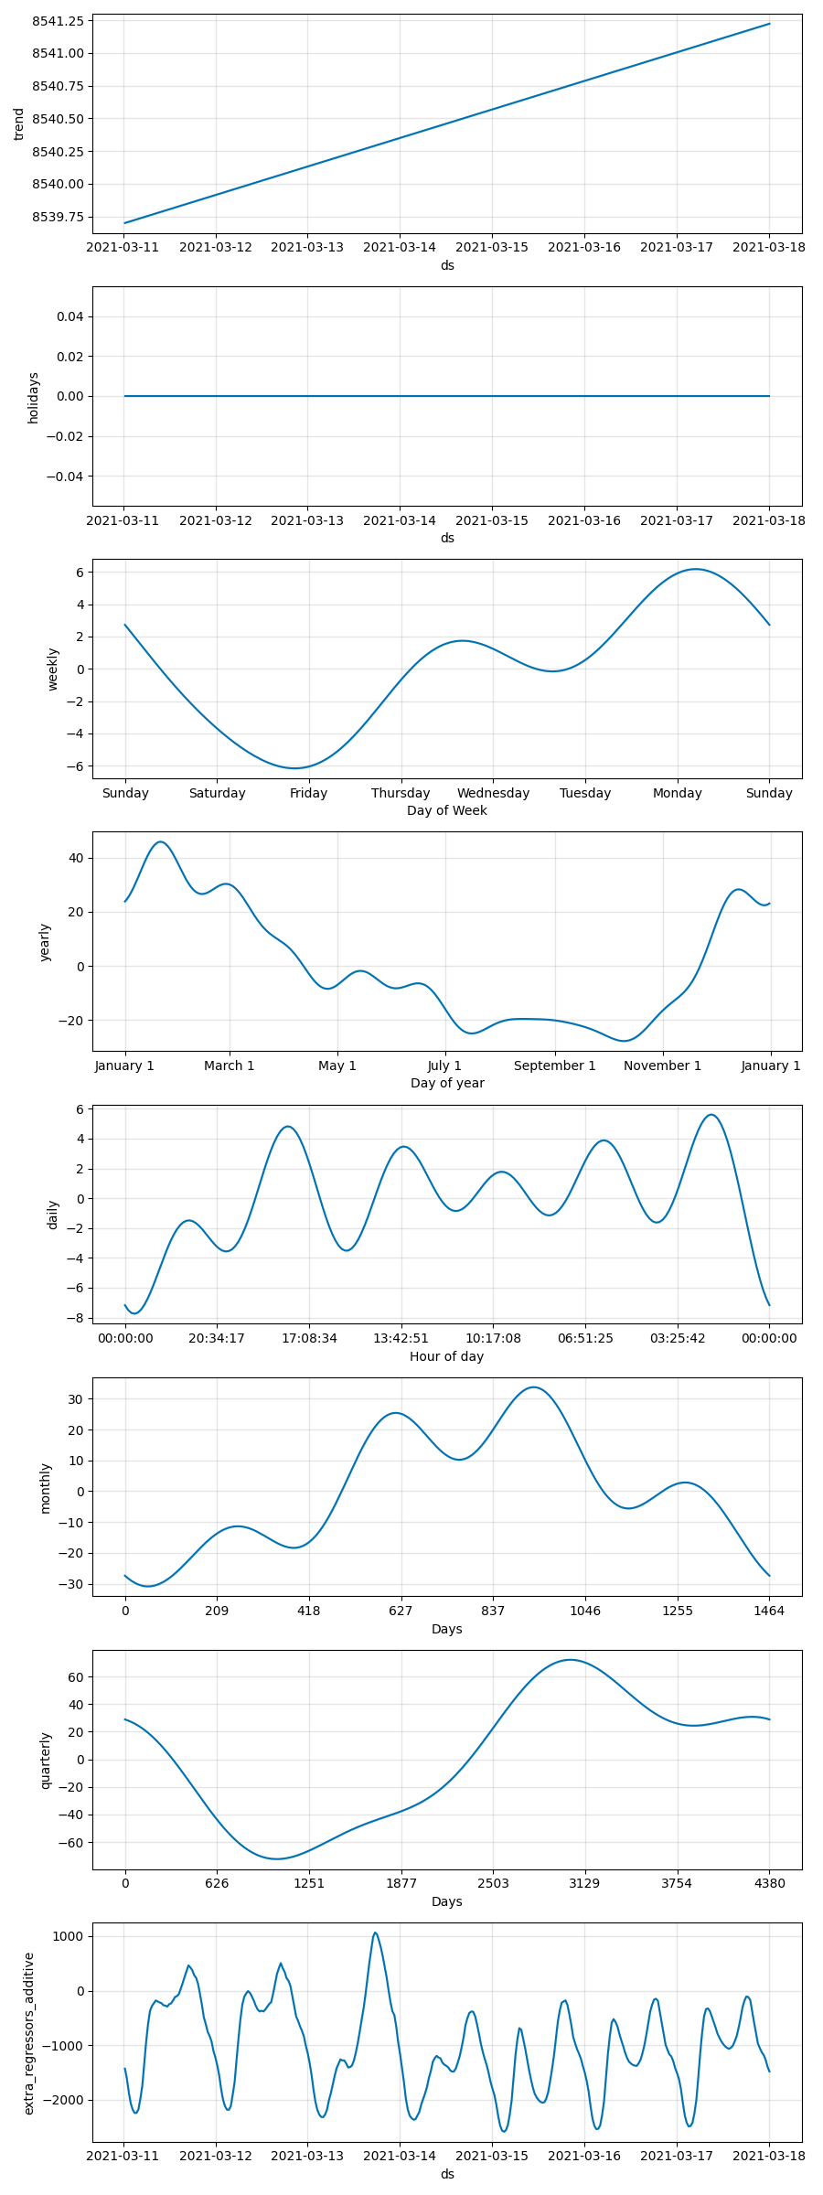

**Developer Notes**

* The model needs to be saved as JSON. Any other format causes problems. The trained model is surprisingly large
* Train time is ~15 minutes on CPU
* Holidays are built in which is cool

**Conclusions:**

I was really surprised with the performance of Prophet. With a **Mean Absolute Error (MAE): 113.3576**, Prophet is the second best performing model in the series and achieves the objective of outperforming the baseline forecast.

**XGBoost and Gradient Boosted Decision Trees (GBDT) for Time Series Forecasting**

Gradient boosted decision trees (GBDT) are a family of machine learning techniques used for regression and classification tasks. They work by sequentially building an ensemble of weak decision tree models in a way that each successive tree corrects the errors made by the previous ones. The final prediction is typically made by aggregating the predictions of all the trees in the ensemble, which improves the model's accuracy and generalisation ability. It is interesting to note that using an ensemble of trained XGB models, an “ensemble of ensembles”, usually outperforms a single model. I don’t understand this behaviour yet.

When applied to time series forecasting, GBDTs can be particularly effective due to their ability to capture complex nonlinear relationships and interactions between features:

1. Feature Engineering: Time series features such as lags, moving averages, and other time-based aggregations are critical for leveraging temporal dynamics, which GBDTs themselves do not inherently model.
2. Handling Seasonality and Trends: Techniques like differencing (to make the series stationary) or adding explicit features that represent the seasonal and trend components can help in improving forecast accuracy.
3. Loss Functions: Depending on the forecasting task, custom loss functions can be designed to penalise forecasting errors differently across time (e.g., more penalty for peak times).

### XGBoost for Time Series Forecasting

XGBoost (Extreme Gradient Boosting) is a specific implementation of gradient boosted decision trees designed for speed and performance. It extends the basic GBDT approach by introducing several additional features:

* User friendly interface, documentation and community: a key consideration when choosing a model is the complexity of implementation, the number of case studies and examples to learn from, and the community supporting that tool. XGBoost ticks the boxes on all three.
* Regularisation: XGBoost incorporates both L1 (Lasso) and L2 (Ridge) regularisation to prevent over-fitting, which is especially useful in time series forecasting where the risk of over-fitting to past trends is high.
* Handling Sparse Data: It can efficiently handle sparse data, which is useful when dealing with many zero or missing values in time series data. Unlike deep learning approaches which do not tolerate Nan values.
* Scalability: XGBoost is highly scalable and can run on multiple CPUs and GPUs, making it suitable for large time series datasets, although at this scale there is little perceptible gain.
* Tree Pruning: Unlike traditional GBDT, XGBoost uses a depth-first approach and prunes trees as it builds them, making the model more efficient and less likely to over-fit.
* Customisable Optimisation Objectives and Evaluation Criteria: Users can define custom loss functions and evaluation criteria, which allows for flexibility to tailor the model specifically for the forecast performance metrics that are most important for their specific application.

XGBoost’s effectiveness is well known ad documented. Many in the data science community refer to it as the “universal swiss army knife” or “universal chain saw” for time series, so I fully expected to get the best results from this approach. I wasn’t disappointed. The model yields **a loss (MAE) of 49.92047** making it the best performing model. I think there is still a lot of room for improvement.

**Sweeps**

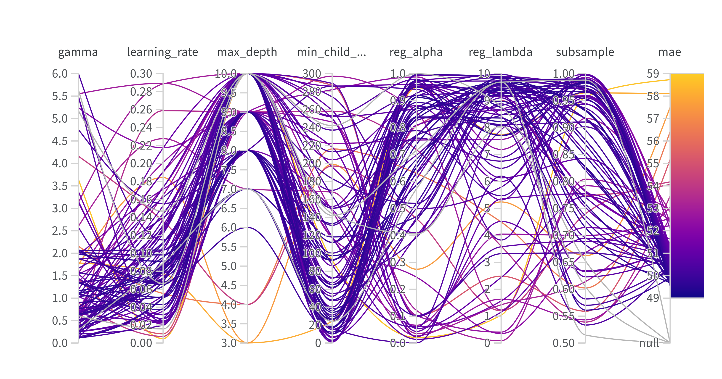

**Hyper-parameter importance**

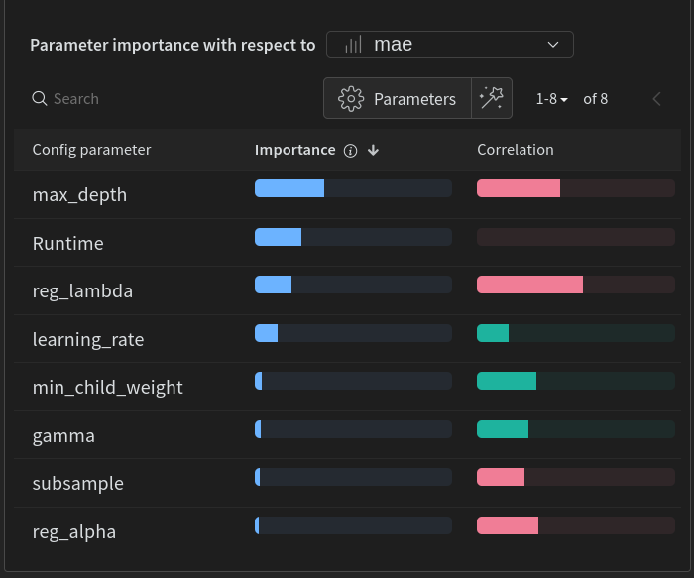

The model optimisation benefited from using either WandB or Optuna to optimise the hyperparameters. The widespread popularity of XGB means that there are integrations built into many optimisation and experiment tracking frameworks. There are also MANY examples of XGB fore time series forecasting available, so its easy to debug and iterate compared to the less popular approaches.

**Forecast vs Actual Plot**

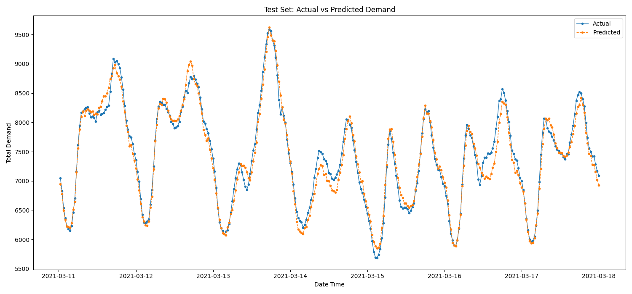

Shapley Values image

**Deep Learning and LSTMs**

Initially I was uncomfortable with the idea of deep learning, and discouraged my team makes from trying deep learning. There were several reasons for this:

* While deep learning has demonstrated excellent results in academic research, and is an area of intense interest, it hasn’t demonstrated the massive increase in performance that deep learning has delivered for other domains like computer vision, language etc.
* Even when superior results are achieved, deep learning generally hasn’t shown that it delivers levels of performance commensurate with the level of required investment in development and overhead for on-going ongoing operations.

All that said, I love deep learning so I succumbed to temptation and tried. I did however maintain realistic expectations about success given our constraints.

**Introduction to the Architecture**

Long Short-Term Memory (LSTM) networks are a type of recurrent neural network (RNN) specifically designed to handle the challenges of learning from sequences of data, making them highly applicable for time series forecasting. LSTMs are adept at capturing long-term dependencies and patterns in time series data, which are crucial for predicting future trends based on past observations. This capability stems from their structure, which includes memory cells and gates that regulate the flow of information, effectively allowing them to "remember" important information over extended periods and "forget" irrelevant details (ref). This makes LSTMs particularly useful in fields using sequence to sequence modelling, and when understanding temporal dynamics is key. Time series fits the bill, and many research papers have shown its effectiveness (ref).

**Notes about development**

I started by building a “minimal model”. This means focusing on the components of the model that are necessary before iteratively refining the model architecture. Specifically these included:

* **Custom Torch Dataset Class**: required to load, pre-process and transform the dataset into a form that can be ingested by the model, specifically torch tensors
* **Custom Torch Model**: uses the base Pytorch implementation of the LSTM, and defines the model architecture by layer, adding features like bidirectionality, hidden units, number of LSTM layers, activation and other layers. The model takes data from the data loader, performs the forward pass through the model, and if conditions are met, saves the checkpoint.
* **Early Stopping class**: The EarlyStopping class in Pytorch is designed to halt the training process of a machine learning model if there's no improvement in the model's loss over a specified number of epochs. During training, the class checks the validation loss against the best recorded score, updates counters or saves the model, effectively preventing over-fitting by stopping the training early when further training does not yield better results.
* **Learning Rate Scheduler**: In many cases, models train more stably when a dynamic learning rate is used. Usually, the fold starts with a higher learning rate, and then progressively reduces as the fold progresses through training.
* **Optimiser**: responsible for updating the parameters (or weights and biases) of the network to minimise the objective function, typically a loss function. The optimiser's task is to find the optimal parameter values for the model that reduce the loss, aiming to improve the model's performance on a given task.
* This model required substantially more raw code than any other approach by a significant margin. Consequently it also required a lot more developer time.
* While the minimal model would train in <10 minutes, once the architecture had stabilised and I began optimising, training times had increased to >5 hours per run, and needed ~20gb of GPU VRAM. This was orders of magnitude more than the other approaches.
* While the performance of the model improved dramatically by the end of the experiment, its performance is still only moderately on par with simpler and computationally cheaper models like Prophet or XGB.

**Learning Rate scheduler experiments**

Torch offers a number of learning rate schedulers, some of which I tested:

* StepLR;
* ExponentialLR;
* CosineAnnealingLR.

The below shows a comparison of learning rate across 10 epochs, 5 folds

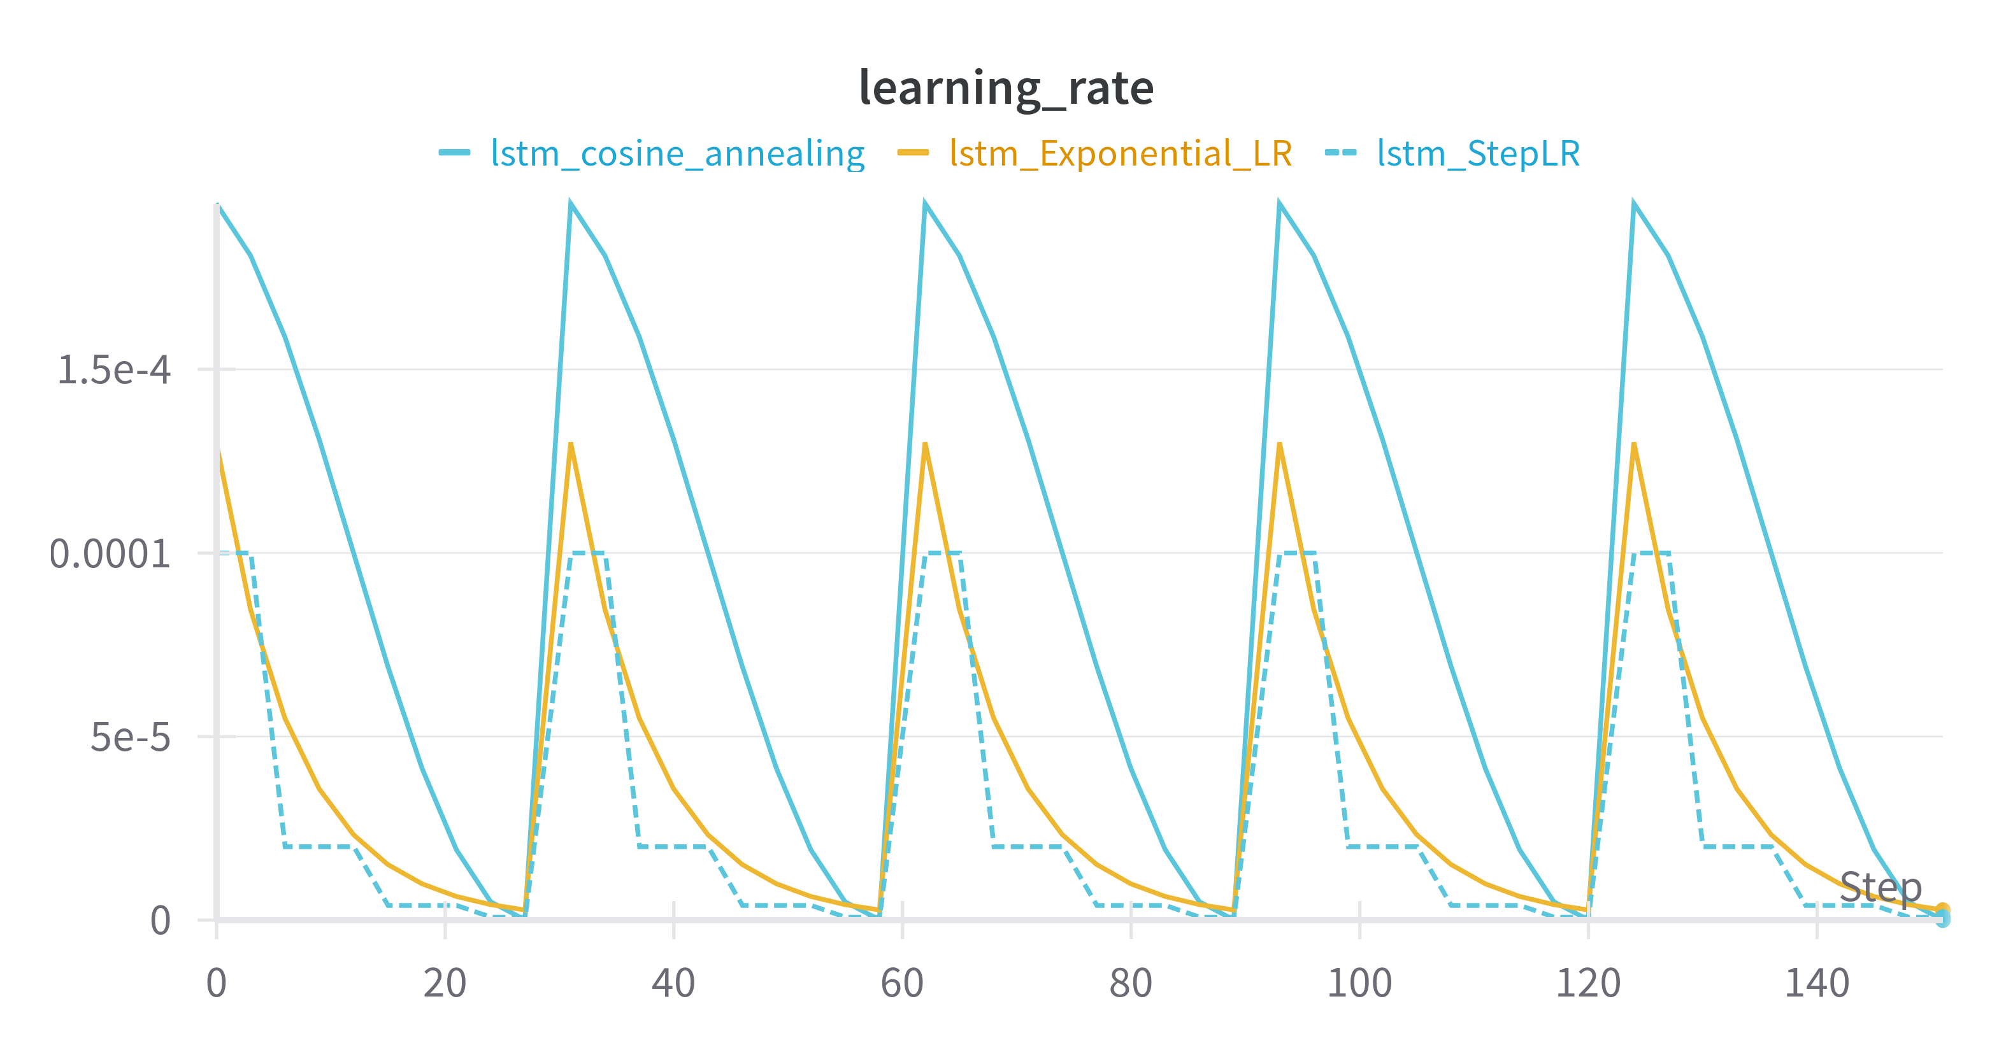

To form an opinion on the relative performance of each scheduler I compared trainling loss, test loss, and generalisation gap

**Training loss**

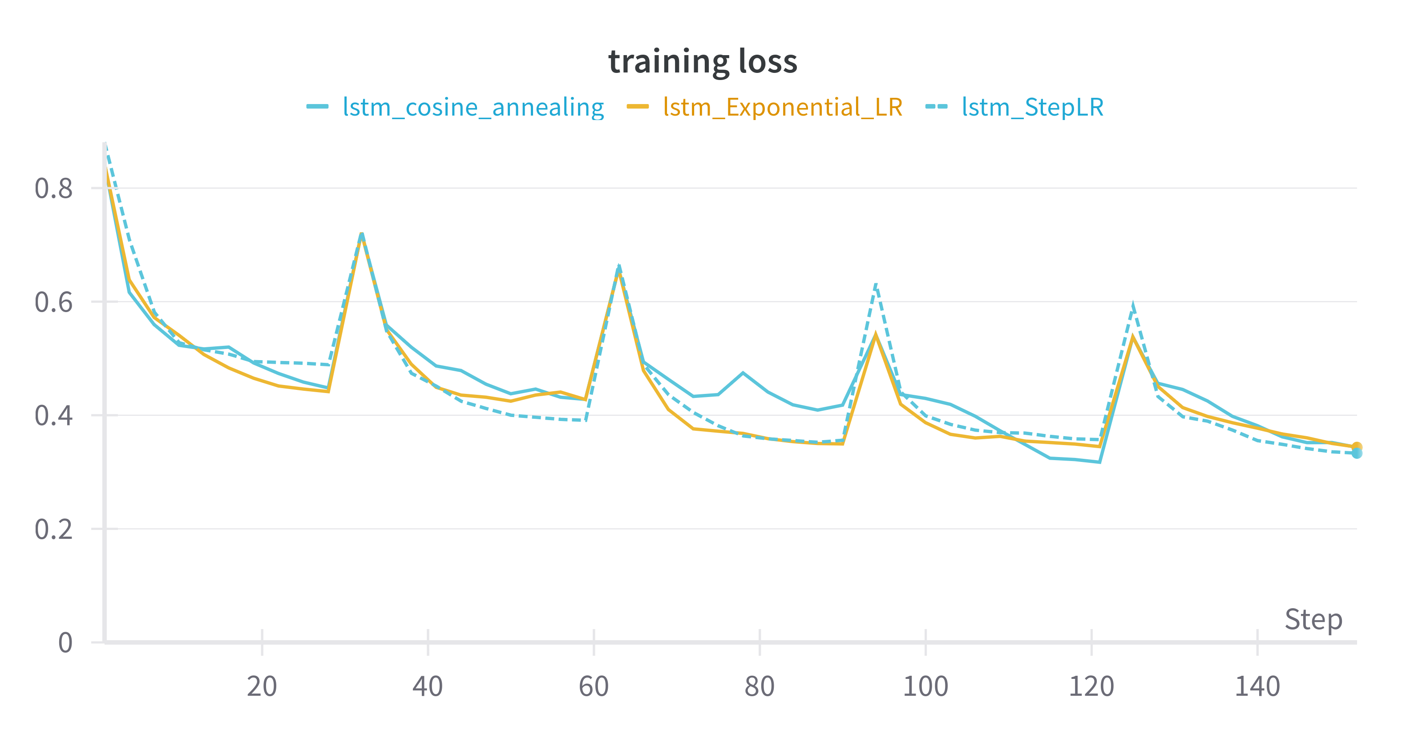

**Test loss**

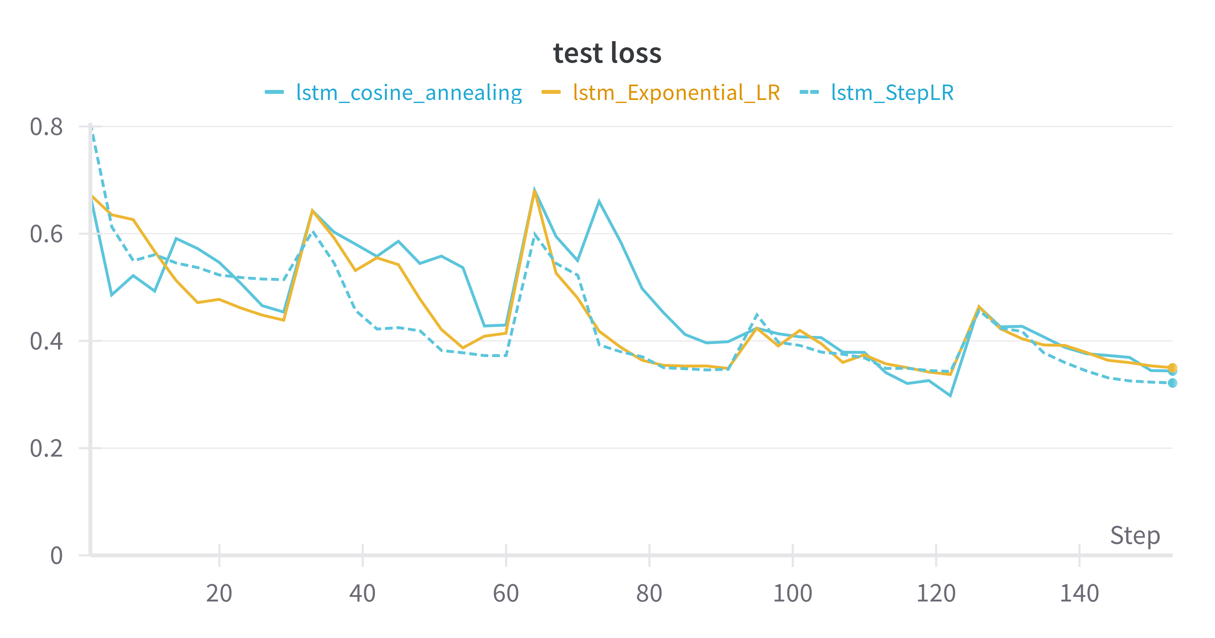

**Generalisation Gap**

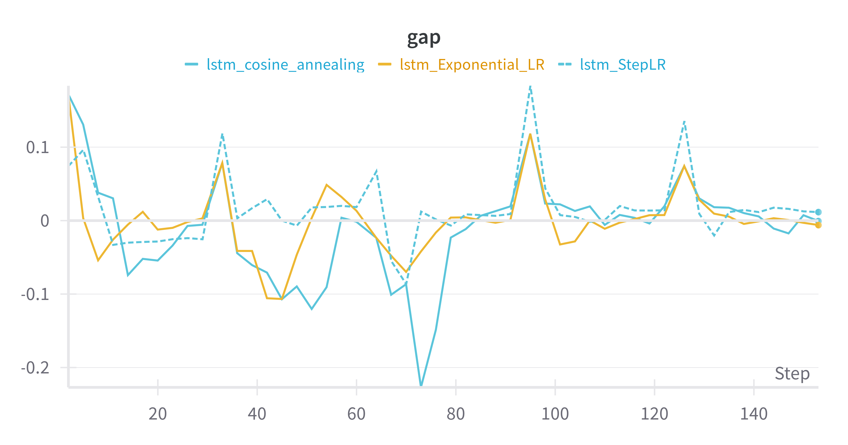

Based on these plots, my conclusion was that StepLR worked the best in this instance. I was surprised by this as it is the most naive of the LR Schedulers.

**Model Depth**

Once Model architecture was stabilised, I began to experiment with depth, yielding the following results. In general model performance increases as I add more depth, more folds and longer epochs, on the condition that I also use learning rate scheduling. I think this is very clear from the following plots:

**training loss:**

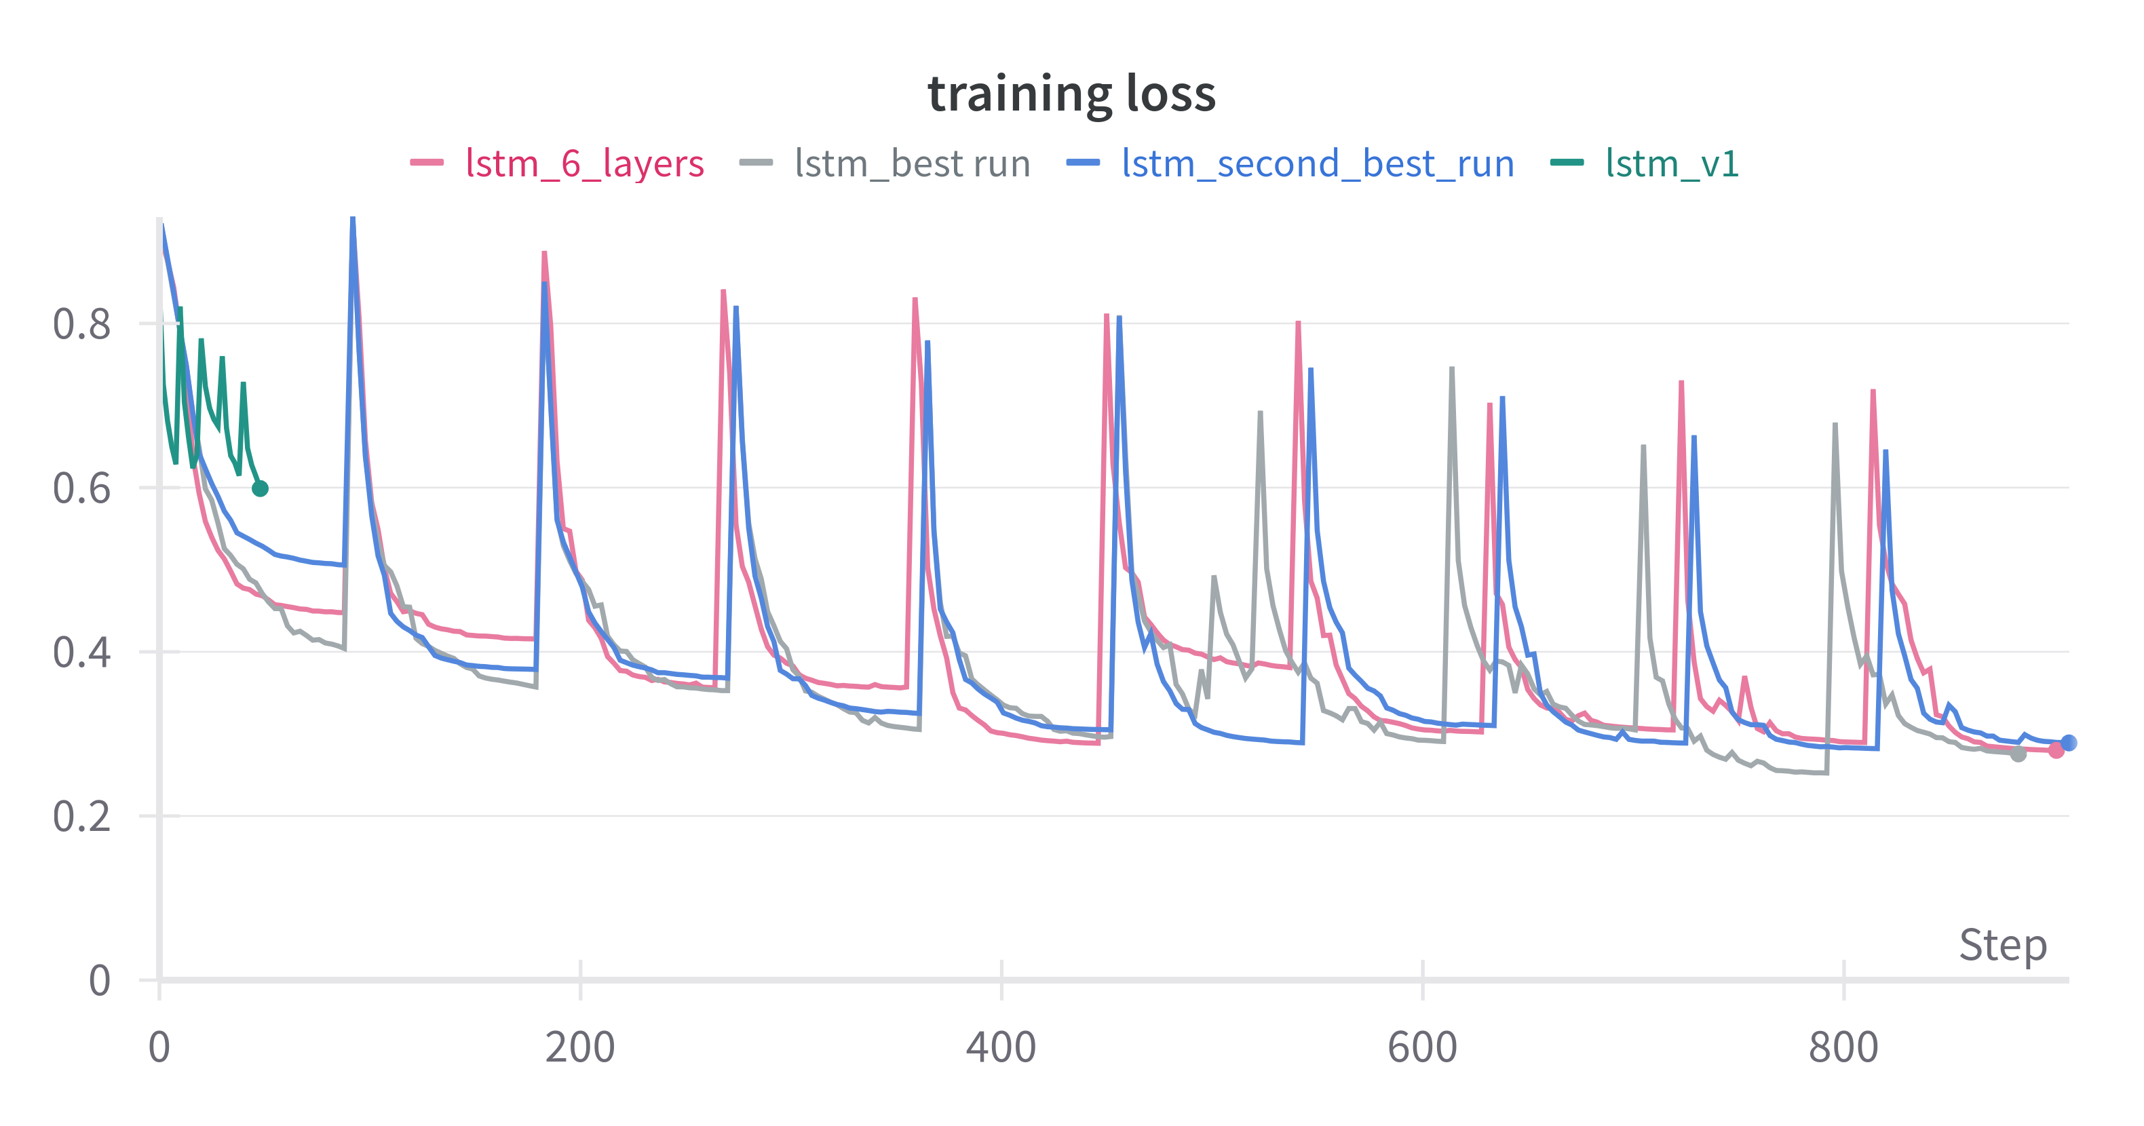

**test loss**

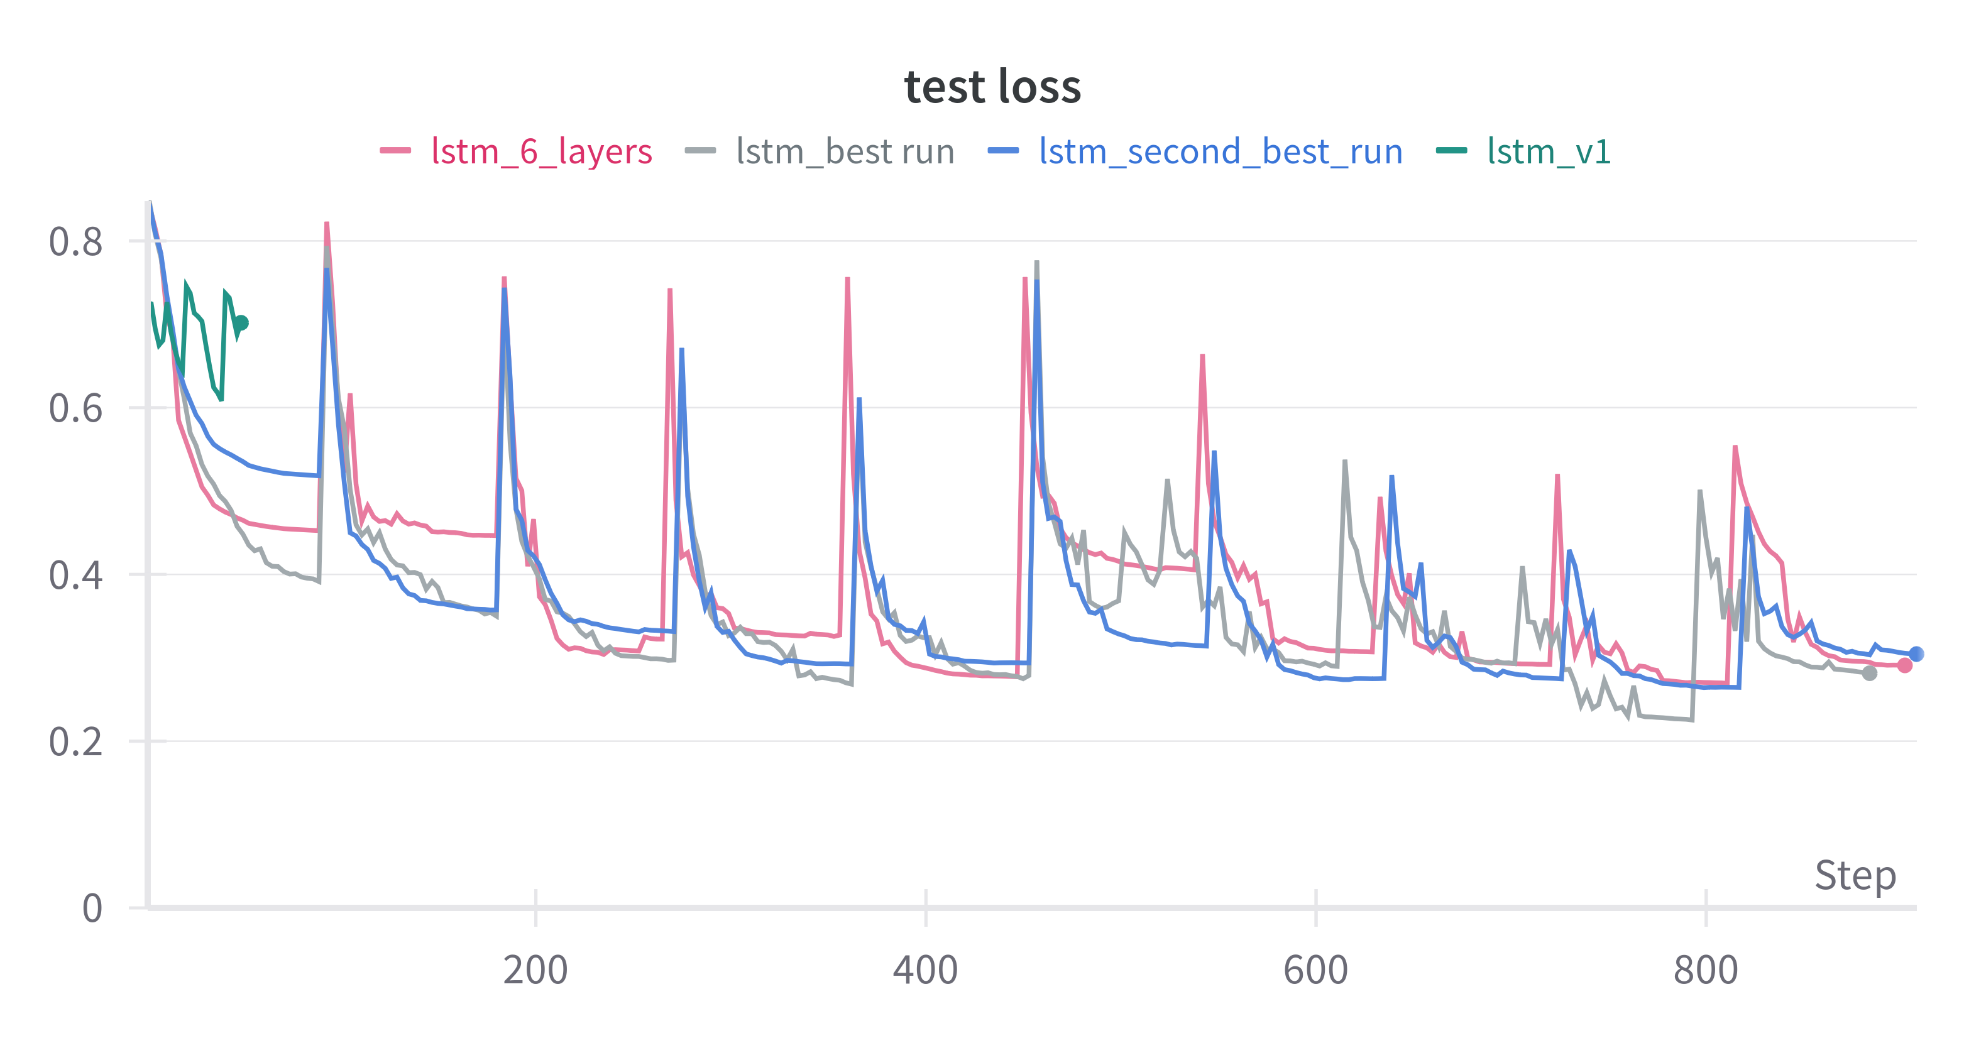

**train loss comparison**

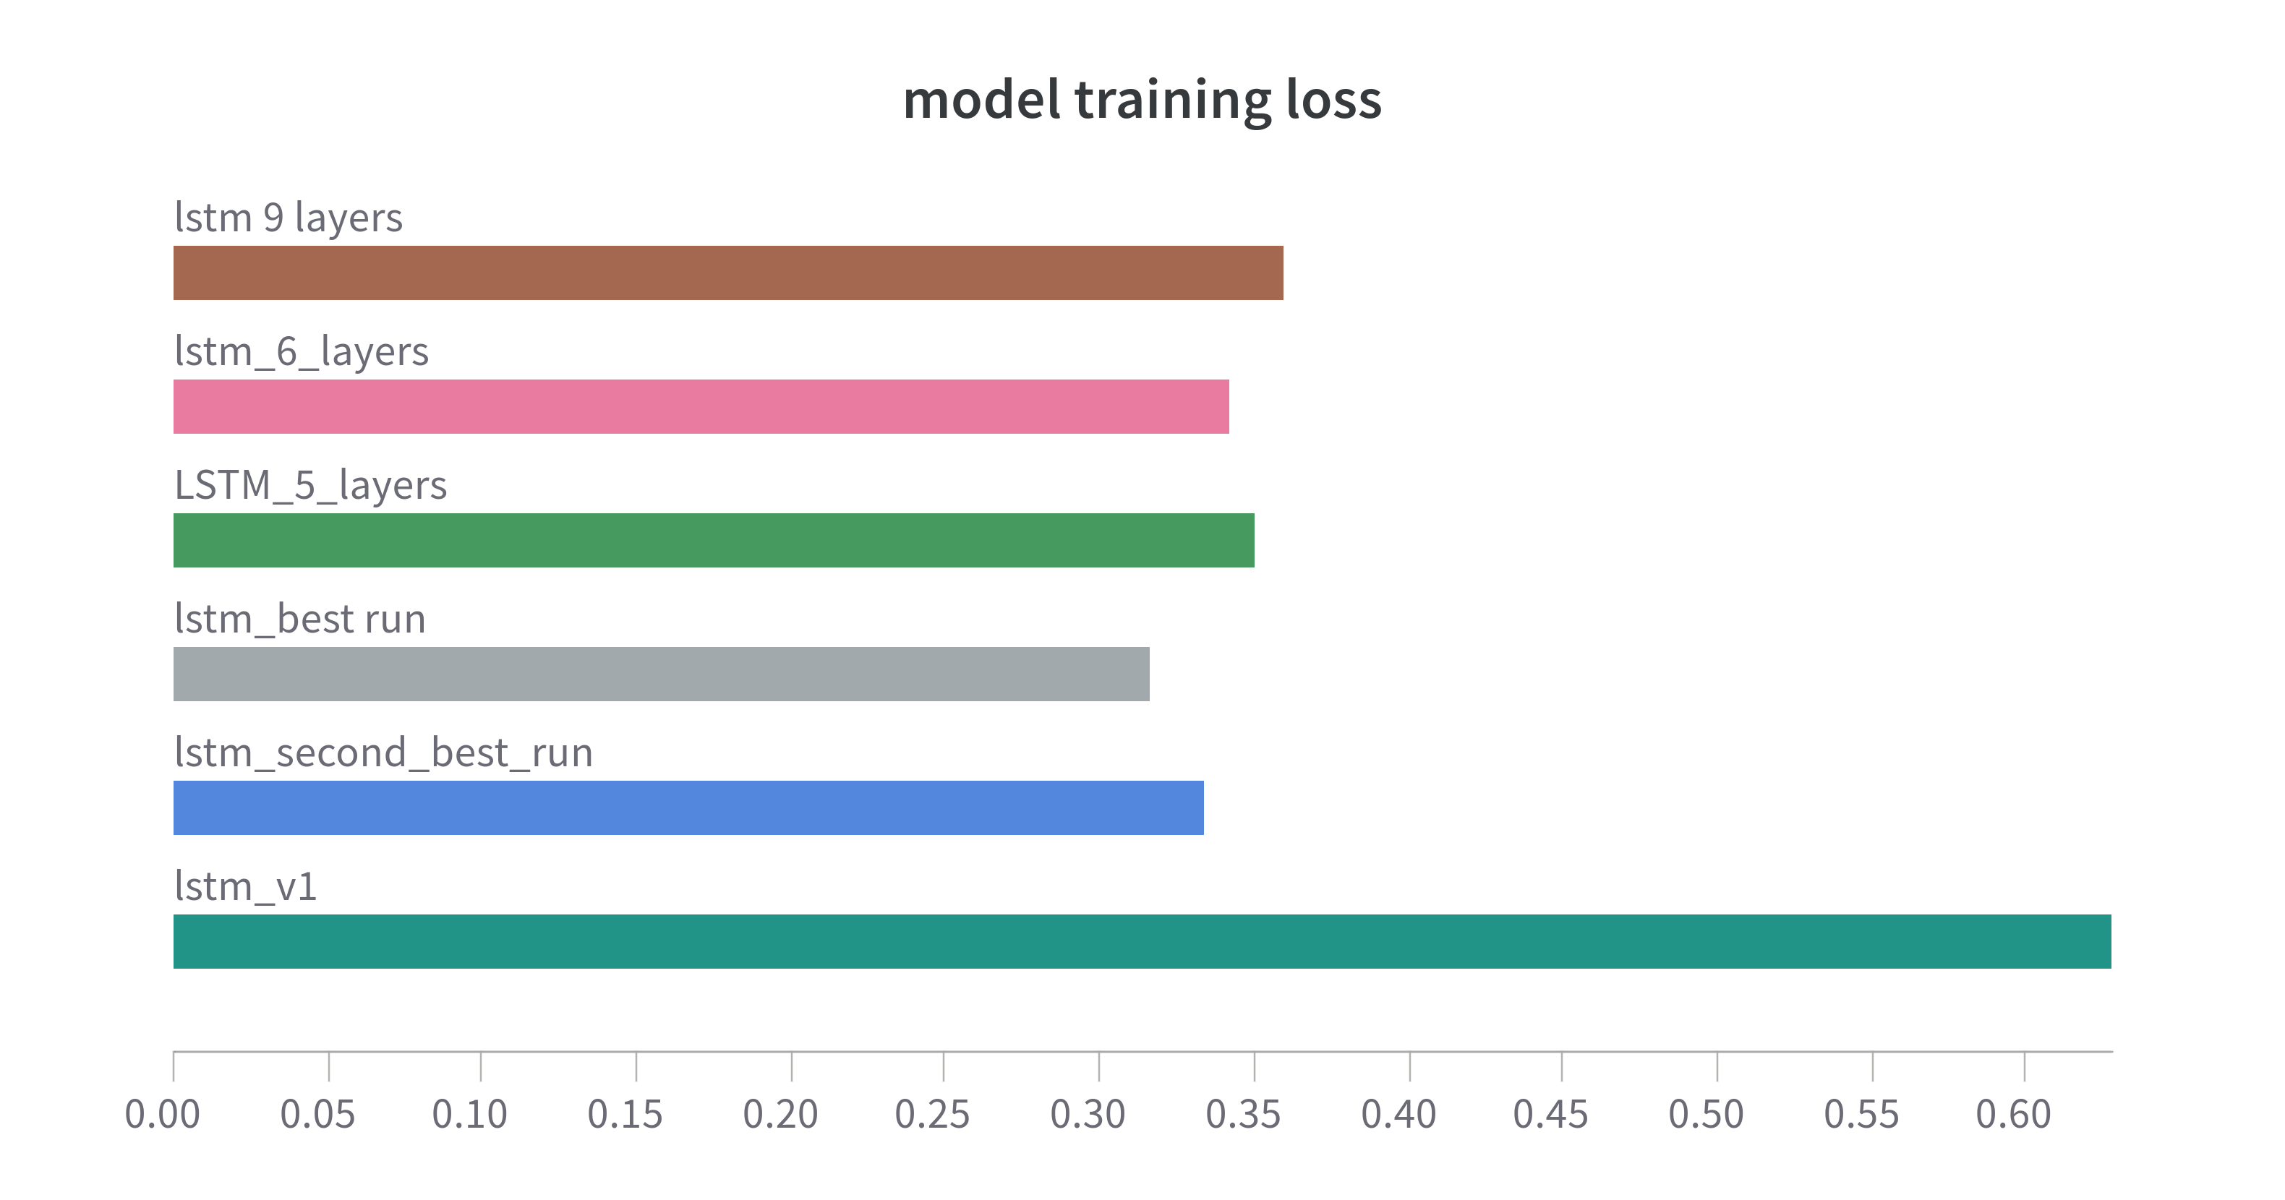

**test loss comparison**

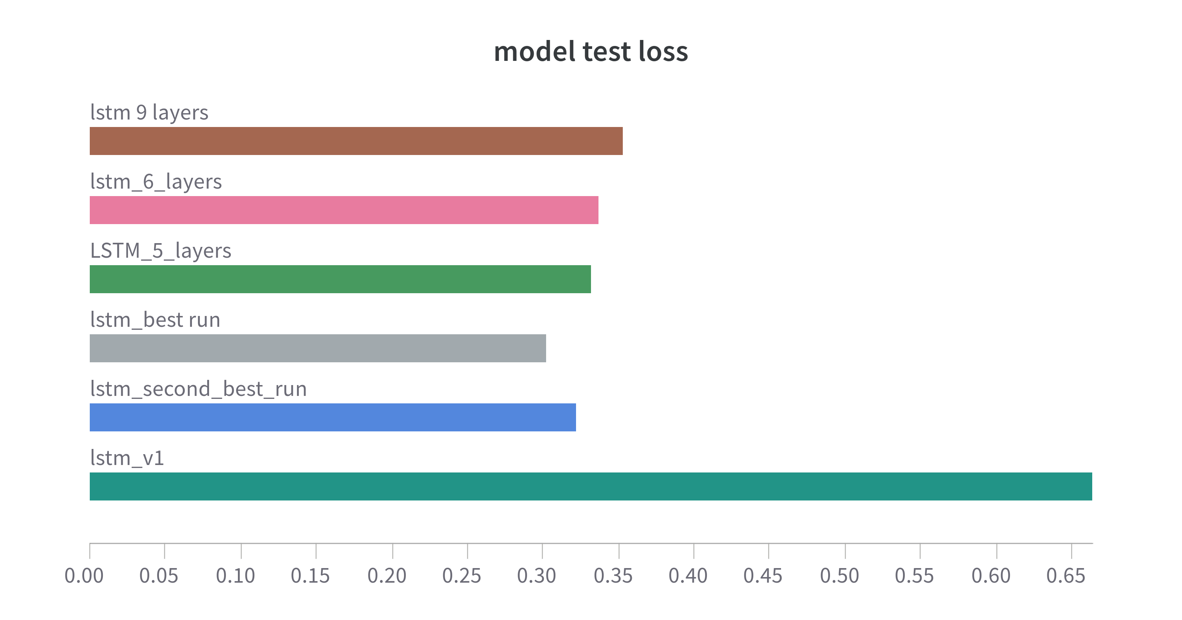

**Generalisation Gap comparison**

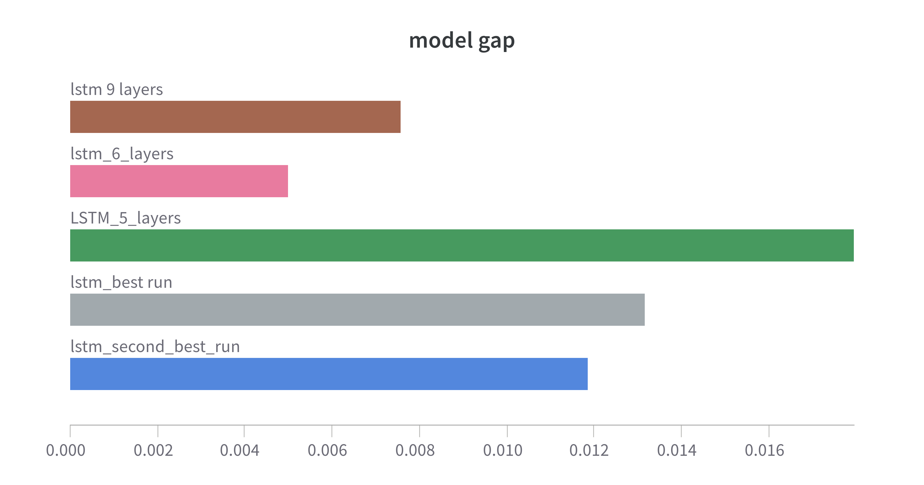

**Observation:**

the changes compared to the minimal model are stark. Model performance improves to a depth of 4 layers, then begins to exhibit a “noisy” generalisation gap. I think 6 layers achieves the best balance of minimising test loss, minimising generalisation gap and model training stability

**Inference Based on LSTM**

We load the trained model from the saved checkpoint and inference against the validation set. Note, pytorch requires both the saved weights and the saved scalars to do inference. It also requires GPU compute:

insert plot of forecast vs actual

Overall I felt disappointed with the results from deep learning. I know that better results are possible, and the progress of the train-test loss curves shows that we’ve made significant progress, however I have not been able to achieve a result that is competitive with Prophet or XGB.

In addition, while I feel certain that its possible to achieve better results using deep learning, there is a very real question about the cost-benefit ratio for this approach. It is more complex and therefore costly to develop, it requires specialised hardware to train and retrain as well as inference. Without knowing the margin value of each increment of accuracy, it is difficult to say with accuracy. We can say that this LSTM model already costs approximately 100x more to train and retrain than a statistical or tree based method.

**Opportunities for Improvement**

* I would circle back and revisit the feature engineering. Having looked at the training plots extensively, I believe the model is picking up “signal” that is not yet sufficiently captured with the engineered features.
* There are so many opportunities for improvement of the LSTM architecture, including the addition of an attention mechanism. You may note that I have experimented with this but have yet to establish the minimal model.
* We should have ensembled models. Given the diversity of models, we would expect an uplift in performance from ensembling. Unfortunately but we ran out of time.
* Transfer learning:

**Summary of Model Performance**

the conclusion is pretty clear: well-tuned statistical models or tree based models, combined with cross validation delivers excellent results for time series.

We’ve developed two models that appear to deliver better performance than the current FORECAST_DEMAND, thus achieving our project objective.

It should be noted that FORECAST_DEMAND is the most informative variable, and obviously builds on the past errors of that model output to improve our models performance. This is a common practice, and there is nothing fundamentally wrong with this, however we should note a point.

By using this variable in our models, we are also potentially introducing any biases or errors “baked in” to that prediction. We should be aware of this.

|  |  |  |  |  |
| --- | --- | --- | --- | --- |
| **Model Name** | **Train Loss (MAE)** | **Test Loss (MAE)** | **Generalisation Gap** | **Validation Loss** |
|  |  |  |  |  |
|  |  |  |  |  |
| Exponential Smoothing |  |  |  |  |
| Prophet | 124.83207 | 113.35761 | 11.47446 | 113.3576 |
| XGBoost | 65.05766 | 106.58374 | 72.91921 | 105.7456 |
| LSTM | 0.27522618255053 | 0.2810852428277 | 0.0000128000000 |  |

Create a dataframe for viz